PRACTICAL
FLEET MANAGEMENT SYSTEM
On
UCS4001
DATABASE MANAGEMENT SYSTEM



SCHOOL OF COMPUTER SCIENCE AND ENGINEERING
IILM UNIVERSITY
JANUARY 2026 – MAY 2026

Submitted To: Submitted By:
MR. ATUL KUMAR Deepti Garkoti(2410030180)
Vaishnavi Dixit(2410030893)
Ayush Bhati(2410030181)
Nitin Yadav(2410030176)
Section:2CSE10
Team: G11

CERTIFICATE

This is to certify that the project entitled “FLEET MANAGEMENT SYSTEM” is a bonafide record of work carried out by GROUP 11, of B. Tech CSE (Data Science), during the academic year 2025–2026.
The work has been completed under my supervision and guidance. The student has demonstrated sincere effort, dedication, and a clear understanding of the concepts of Database Management Systems, including Entity-Relationship (ER) modelling, relational schema design, normalization techniques, and implementation of SQL queries.
The project report has been examined and is approved as it satisfies the academic requirements prescribed by the institution.

Project Guide:
Name: Mr. Atul Kumar
Department: Computer Science and Engineering

PROBLEM STATEMENT
In many transportation and logistics organizations, vehicle-related information such as driver details, vehicle records, trip history, maintenance schedules, and fuel consumption is often managed manually or stored in unorganized systems. This manual approach leads to several problems including data redundancy, data inconsistency, difficulty in tracking records, and lack of proper coordination between different operational activities.
When records are maintained manually, it becomes difficult to:
- Track which driver is assigned to which vehicle
- Monitor vehicle trip details and distance covered
- Maintain proper maintenance records
- Track fuel consumption and expenses
- Generate accurate reports for decision-making
Manual systems increase the risk of data loss, duplication, and human error. Retrieving specific information from physical registers or scattered files consumes time and reduces operational efficiency. Moreover, without a structured database system, it becomes challenging to maintain data integrity and ensure reliable record management.
To overcome these issues, there is a need for a structured and centralized database system that can efficiently manage all vehicle-related information. The proposed Fleet Management System aims to design and implement a Database Management System (DBMS) that organizes data using entities, attributes, and relationships. The system will allow systematic storage, retrieval, updating, and management of data related to drivers, vehicles, trips, maintenance, and fuel records.
The project focuses on designing an ER model to represent real-world relationships, converting it into a relational schema, applying normalization techniques to eliminate redundancy, and implementing SQL queries to perform database operations. The objective is to create an efficient, reliable, and scalable database solution that improves operational efficiency and ensures data consistency.

ER DIAGRAM OF FLEET MANAGEMENT SYSTEM
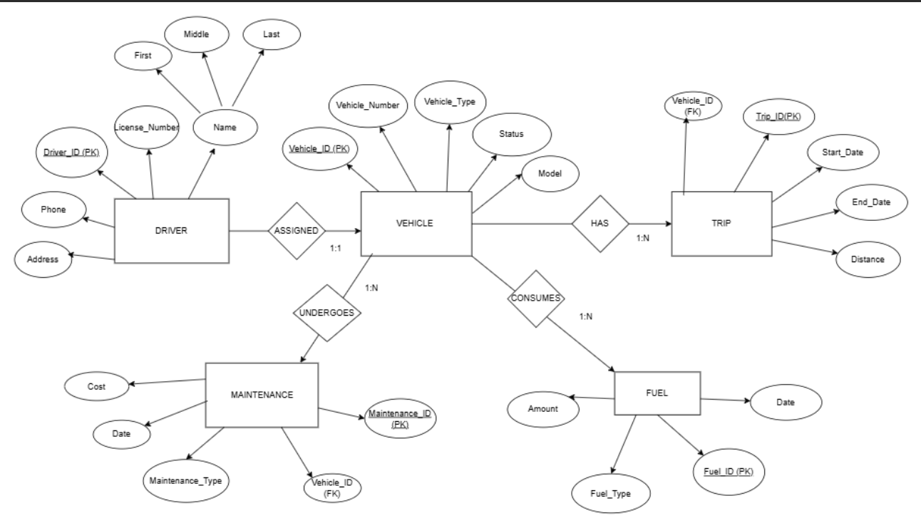
ENTITY RELATIONSHIP (ER) DIAGRAM

What is an ER Diagram?
An Entity Relationship (ER) Diagram is a graphical representation of the structure of a database. It shows:
- Entities (objects)
- Attributes (properties of objects)
- Relationships (how entities are connected)
The ER model was introduced by Peter Chen (1976) and is widely used for designing relational databases.
It helps in:
- Understanding data requirements
- Reducing redundancy
- Designing normalized databases
- Visualizing relationships clearly
What is an Entity?
An Entity is a real-world object or thing about which data is stored in the database.
Entities are represented by rectangles in ER diagrams.
Types of Entities:
- Strong Entity
- Weak Entity
In your diagram, all are strong entities.
🔹 Entities in Your ER Diagram
1. DRIVER
Represents drivers who operate vehicles.
2. VEHICLE
Represents vehicles used for trips.
3. TRIP
Represents trips made by vehicles.
4. MAINTENANCE
Represents maintenance records of vehicles.
5. FUEL
Represents fuel consumption records.
What is an Attribute?
An Attribute is a property or characteristic of an entity.
Attributes are represented by ovals.
Example:
Driver has:
- Name
- Phone
- License Number
🔹 Types of Attributes
1. Simple Attribute
Cannot be divided further.
Example: Phone, Model
2. Composite Attribute
Can be divided into smaller parts.
Example: Name → First, Middle, Last
(Your diagram shows composite attribute for Name.)
3. Single-Valued Attribute
Stores one value only.
Example: License_Number
4. Multi-Valued Attribute
Stores multiple values.
(Not clearly shown in your diagram.)
5. Derived Attribute
Calculated from other attributes.
Example: Age (derived from DOB)
Attributes of Each Entity (From Your Diagram)
🔹 DRIVER Entity
Attributes:
- Driver_ID (Primary Key)
- Name (Composite → First, Middle, Last)
- License_Number
- Phone
- Address
Primary Key: Driver_ID
(Primary key uniquely identifies each record.)
🔹 VEHICLE Entity
Attributes:
- Vehicle_ID (Primary Key)
- Vehicle_Number
- Vehicle_Type
- Status
- Model
Primary Key: Vehicle_ID
🔹 TRIP Entity
Attributes:
- Trip_ID (Primary Key)
- Vehicle_ID (Foreign Key)
- Start_Date
- End_Date
- Distance
Primary Key: Trip_ID
Foreign Key: Vehicle_ID
🔹 MAINTENANCE Entity
Attributes:
- Maintenance_ID (Primary Key)
- Vehicle_ID (Foreign Key)
- Maintenance_Type
- Date
- Cost
Primary Key: Maintenance_ID
Foreign Key: Vehicle_ID
🔹 FUEL Entity
Attributes:
- Fuel_ID (Primary Key)
- Vehicle_ID (Foreign Key)
- Fuel_Type
- Date
- Amount
Primary Key: Fuel_ID
Foreign Key: Vehicle_ID

What is a Relationship?
A Relationship shows how two or more entities are connected.
Relationships are represented by diamonds.

Relationships in Diagram
1. ASSIGNED
Between DRIVER and VEHICLE
Meaning:
A driver is assigned to a vehicle.
Cardinality: 1 : 1
One driver is assigned to one vehicle.
2. HAS
Between VEHICLE and TRIP
Meaning:
A vehicle can have multiple trips.
Cardinality: 1 : N
One vehicle → Many trips

3. UNDERGOES
Between VEHICLE and MAINTENANCE
Meaning:
A vehicle undergoes maintenance.
Cardinality: 1 : N
One vehicle → Many maintenance records

4. CONSUMES
Between VEHICLE and FUEL
Meaning:
A vehicle consumes fuel.
Cardinality: 1 : N
One vehicle → Many fuel records

What is Cardinality?
Cardinality defines the number of instances of one entity that can be associated with another.
Types:
- One-to-One (1:1)
- One-to-Many (1:N)
- Many-to-Many (M:N)
In your diagram:
Relationship | Type
DRIVER – VEHICLE | 1:1
VEHICLE – TRIP | 1:N
VEHICLE – MAINTENANCE | 1:N
VEHICLE – FUEL | 1:N

What is Primary Key?
A Primary Key:
- Uniquely identifies each record
- Cannot be NULL
- Cannot be duplicate
Example:
Driver_ID
Vehicle_ID
Trip_ID

What is Foreign Key?
A Foreign Key:
- Links two tables
- References primary key of another table
Example:
Vehicle_ID in Trip table
Vehicle_ID in Maintenance table

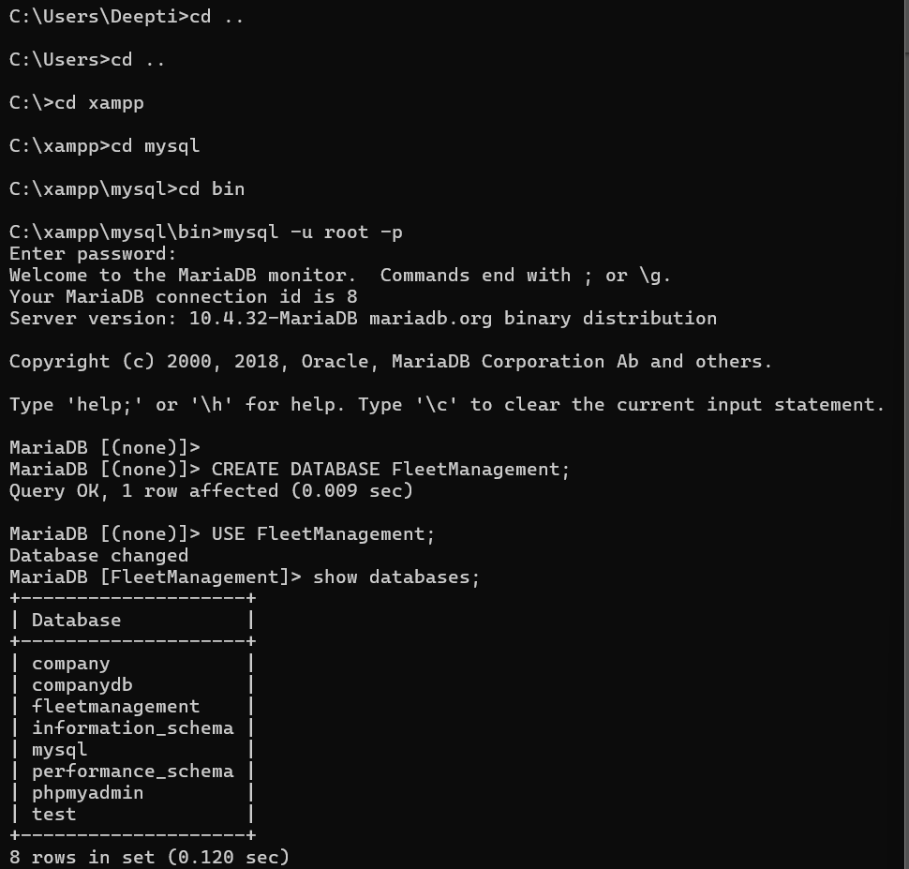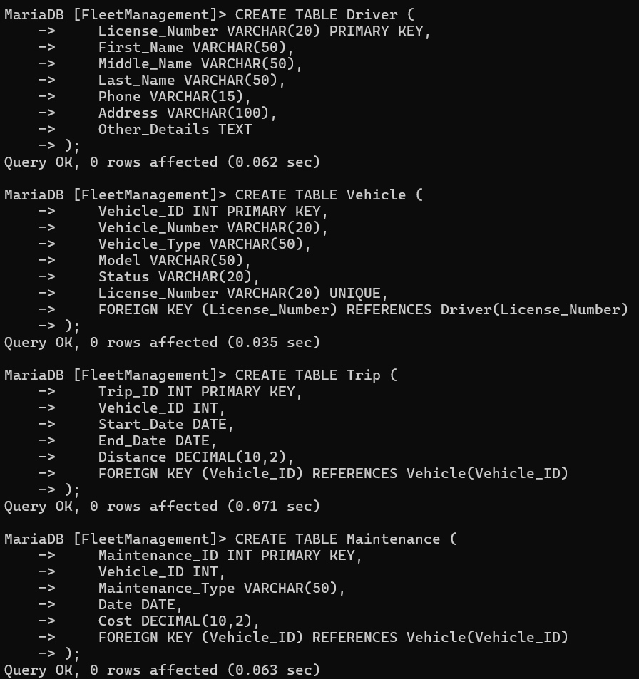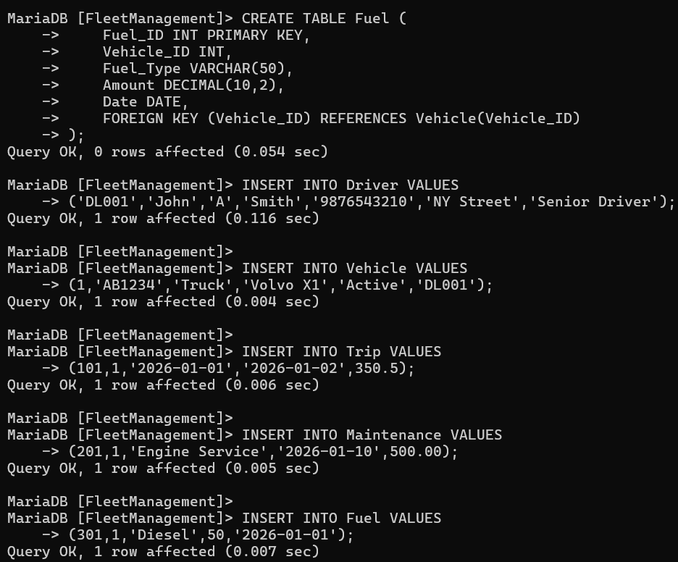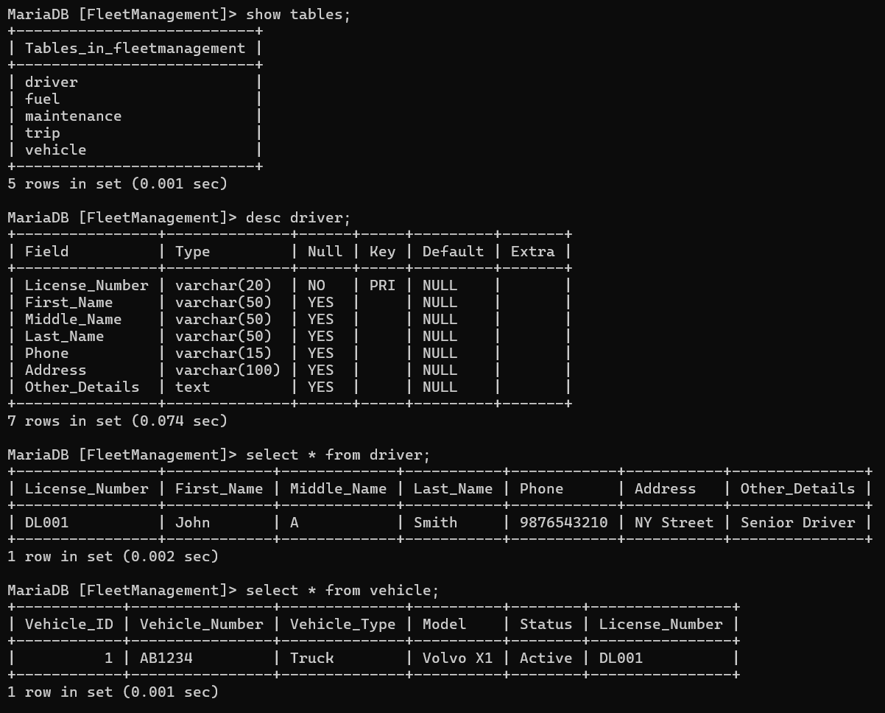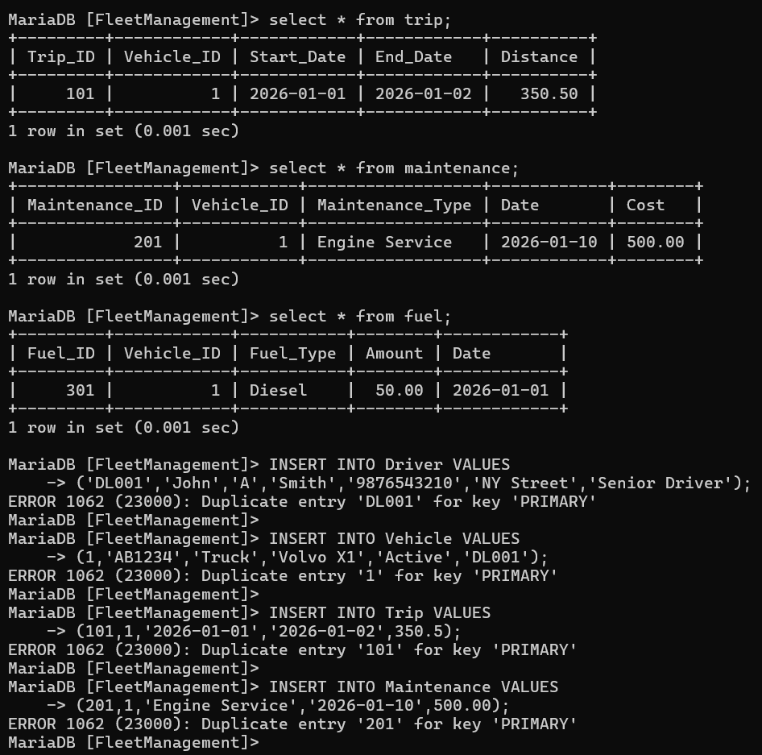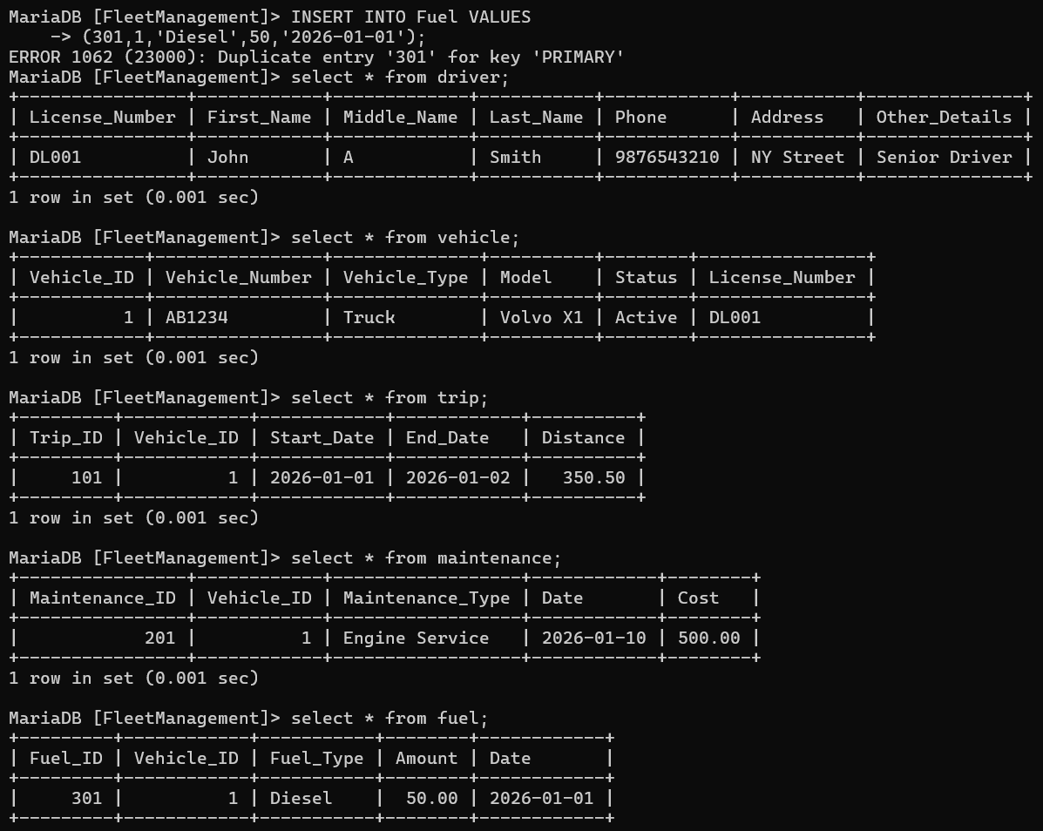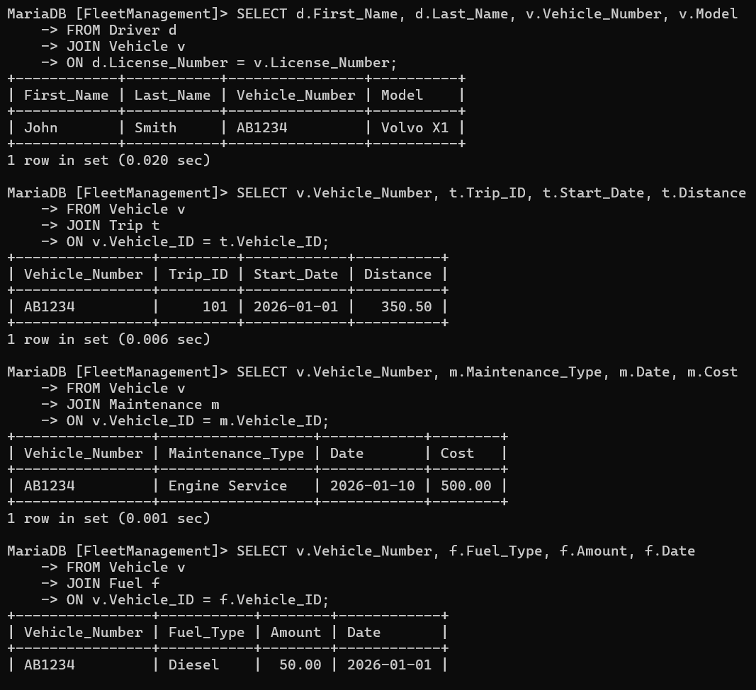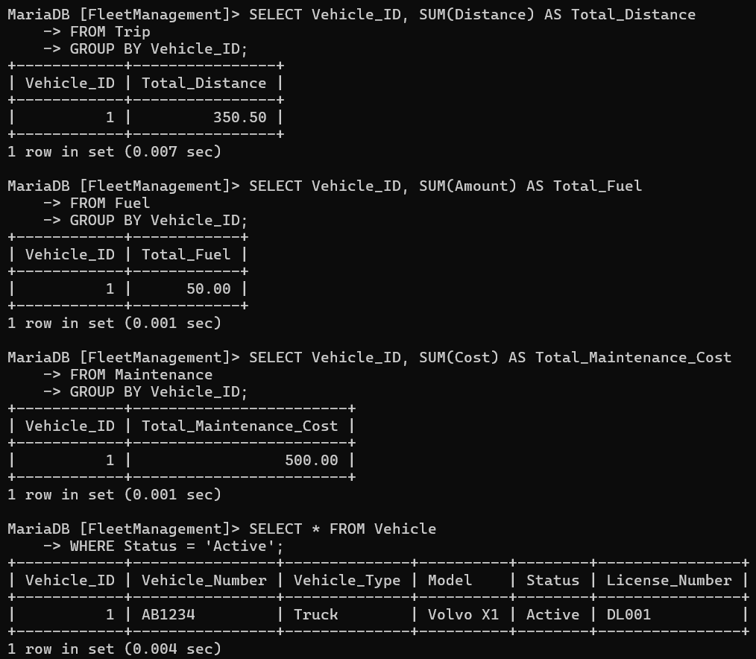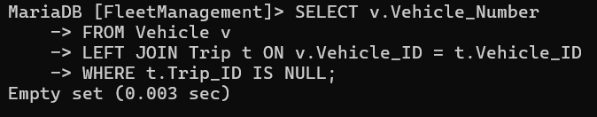

CONCLUSION

The Fleet Management System designed in this project successfully demonstrates the practical implementation of Database Management System concepts using Entity-Relationship modelling and relational schema design. The system efficiently organizes and manages data related to drivers, vehicles, trips, maintenance records, and fuel consumption.
Through the development of the ER diagram, the relationships between different entities were clearly identified and structured. The use of primary keys and foreign keys ensures data integrity and establishes meaningful connections between tables. The application of one-to-one and one-to-many relationships accurately represents real-world interactions within the system.
Normalization techniques were applied to eliminate data redundancy and maintain consistency in the database. By organizing the data into separate but related tables, the system improves efficiency, reduces duplication, and enhances data accuracy. The structured approach ensures that updates, insertions, and deletions can be performed without affecting data reliability.
The SQL queries implemented in this project demonstrate how the database can perform essential operations such as creating tables, inserting records, updating information, retrieving data, and deleting records. These operations confirm that the designed database is functional and capable of handling real-world scenarios effectively.
Overall, this project provides a clear understanding of how ER modelling, relational schema conversion, and SQL implementation work together to build a well-structured database system. The knowledge gained from this project strengthens practical skills in database design and management, which are essential for real-world software development and data management applications.
In conclusion, the Fleet Management System serves as a comprehensive example of applying DBMS concepts to solve real-world data management problems efficiently and systematically.

